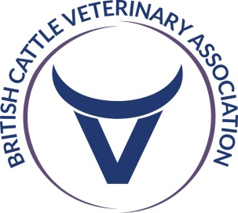
BCVA Congress 2024
Celtic Manor Resort, Newport, Wales
17th – 19th October

Exhibition Deadlines

Stand/Sponsorship registration - by 24th May
Stand balance payment – by 2nd September
Cattle Practice Adverts, Inform BCVA you wish to book an advert – by 16th August
Cattle Practice Adverts, Copy of advert to BCVA – by 6th September
Delegate Flyers, Electronic copy to BCVA for approval – by 6th September
Rep registrations – by 13th September
Forms back to Ford & Barley - by 13th September
Delegate Flyers, Hard copies to BCVA Office – by 11th October
Stand Deliveries to Venue – 15th & 16th October
Stand building – 16th October (3pm – 6pm) and 17th October (8am – 9:30am)
Delegate Registration – 17th October from 9am
Stand dismantling – 19th October (2pm – 4pm)
After event collection – 21st October

PLEASE KEEP A COPY OF THIS

