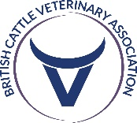

Steward Application Form
To apply please complete this form and return it to the BCVA office via post or email:
Address: BCVA Office, 17 The Glenmore Centre, Waterwells Business Park, Quedgeley, GL2 2AP
Email: congress2024@bcva.co.uk
Name
Veterinary School
Email
Year of study as of October 2024 |  |  |  |  | Expected Qualification Year
Are you a FAVS Member?
Yes |  | No |  | Prefer not to say
What area are you interested in working in post graduation?
Farm Animal |  | Mixed |  | Small Animal |  |  | Undecided/Not sure
Prefer not to say |  | Other
Do you have any relevant experience, or have you stewarded at BCVA Congress or other events?
Please list 5 Bullets points on why you would like to steward at BCVA Congress

To steward you will be expected to available 12:00 Wednesday 16th October – 16:30 Saturday 19th October

